iSobot Controllers

Robotics III ECE 410

Edited by
Waleed Alhaddad (alhad@pdx.edu)
Saad Alaskar (alq8t@yahoo.com)

6/13/16

Author: Mathias Sunardi

Introduction
This is a report on the system to control an iSobot humanoid robot using custom programs such as Python, C, C++, etc. In this report, the programming language used is Python due to the simplicity of accessing/communicating with the serial port. This system was built upon the work done by Aditya Bhutada’s in his MS thesis [1].

Components
The components involved in this system includes:
- Python programming language (http://www.python.org/getit/)
- PySerial – serial port module for Python (http://pyserial.sourceforge.net/)
- Arduino Duemilanove/Uno board with IR emitter circuit
- Arduino 1.0 IDE (http://arduino.cc/en/Main/Software)

Two pieces of software were written:
- isobot.py – a Python module defining the iSobot class
- isobotIR.ino – the Arduino program to translate command bytes to IR emissions understood by the iSobot

I will first discuss the isobot.py module, then the Arduino component.

Python – isobot.py

IMPORTANT PREREQUISITES: install Python, and the PySerial module. Simply, I recommend installing Python version 2.7.x (I don’t guarantee the code I provide below will work with other Python versions). Please refer to their documentation on how to install them – it’s quite straightforward and involves no manual configurations at all.

The isobot.py is a Python module that contains the definition of the “iSobot” class. It utilizes the PySerial module to connect to the serial port (in this case, a USB port).
The full code is provided in Appendix A.

The module does a few things:
- Defines an “iSobot” class
- In the class, over 200 iSobot command bytes are defined as constants. The bytes were obtained from: http:#minkbot.blogspot.com/2009/08/isobot-­‐ infrared-­‐remote-­‐protocol-­‐hack.html
- Communicates via the serial port (e.g. USB) to an infrared (IR) emitter box (controlled by an Arduino board, built by Aditya Bhutada) to transmit the commands to the iSobot robots. The serial port settings are shown in Table 1 (from [1]):

Table 1: Serial Port settings
Setting | Value
Baud Rate | 38400
Data bits | 8
Stop bit | 1
Parity | None
Handshaking | None

- Calculates the checksum of the command string, and format the command strings.
- Allows users to send/specify commands to iSobot in Mode A and/or Mode B.
- Currently only supports iSobot Type 1 commands (support for Type 0 commands will be added later).

How to use it:
- Normally, you would write some sort of a Python script where you can specify the sequence of actions you want iSobot to do.
- To test/see how it works, just use it from the Python shell:
- Go to the directory where the isobot.py file is located:
~$ cd directory-where-isobotpy-located/
~$ ls isobot.py
- Load the Python shell:
~$ python
Python 2.7.1 (r271:86832, Jun 16 2011,
16:59:05)
[GCC 4.2.1 (Based on Apple Inc. build 5658) (LLVM build 2335.15.00)] on Darwin
Type "help", "copyright", "credits" or "license" for more information.
>>>

- Load the isobot module:
>>> import isobot
>>>
- Create an instance of the iSobot class. Give the port name of the
USB/serial port you are using to connect the IR box1 (make sure it is plugged in before you call this – otherwise, it will return an error):
>>> import isobot
>>> bot = isobot.iSobot(‘/dev/tty.usbserial- A9007KX5’)
>>>
- Try the lazy method to execute a Type 1 command:
isobotDoType1(action, channel=0, repeat=3)

Notice the parameters:
  - action = the command byte. This argument is required.
  - channel (=0 for Mode A, =1 for Mode B). This argument is optional. If you don’t give provide this argument, the method defaults to 0 (Mode A).
  - repeat (integer – 0 to whatever). This argument is optional. If you don’t provide this argument, the method defaults to 32.
- Let’s try the walking forward command for an iSobot in Mode B.
>>> bot.isobotDoType1(bot.CMD_FWRD, 1)

Note: that we are calling the value of the walk forward byte as “bot.CMD_FWRD” – this is because the command bytes are defined as constants in the iSobot class, so you do have to refer to them as an instance variable.
- You should see the output as something like this:
>>> bot.isobotDoType1( bot.CMD_FWRD, 1, 300 )
Command string: ['2', '9', 'b', '7', '0', '3', '\r']

1 In Windows, it’s usually ‘COM#’ where # is some number (e.g. COM4, COM5, etc.)
2 Some commands/actions must be sent continuously to the iSobot for it to perform the action. For example: walking forward. To make iSobot take multiple steps, the ‘walk forward’ byte must be sent continuously. Sending the command 300 times make the iSobot take about 4 steps. However, most of the other commands may only need to be sent once or twice. For example: saying hello.

Tx 0:
port is open Sending command...

hex: 2
hex: 9 hex: b hex: 7
hex: 0
hex: 3 hex:
------------------

Tx 1:
port is open Sending command...

hex: 2
hex: 9 hex: b hex: 7
hex: 0
hex: 3 hex:
------------------

Tx 2:
port is open Sending command...

… edited …

The hope is you would use this lazy method most of the time. If you do want to have finer control over this class, other functions and methods3 are available to you as well:
- makeCmd(self, ch, type, cmd1, cmd2=0)
This function will construct the iSobot command string and return it in a hexadecimal string. I provided a detailed explanation on how the command string is constructed in the source code. See the comments above the implementation of this method in Appendix A.
  - This function takes the parameters:
▪▪ ch : channel – 0 for Mode A, 1 for Mode B

3 Just as a distinction in programming jargon: method is a procedure that doesn’t give any return value, function is procedure that returns a value

▪▪ type : command type – 0 for Type 0, 1 for Type 1
▪▪ cmd1 : command Byte 1. Used in command Type 0 and 1. (Type 1 only takes one byte)
▪▪ cmd2 : command Byte 1. Used only in command Type 0 (i.e.
Type 0 takes two bytes). Default 0
o This function returns the command string in hexadecimal
- formatCmd(self, cmd)
This function will convert the hexadecimal string into an array of hexadecimal characters.
  - This function takes the argument:
▪▪ cmd : a raw hex string. Pass the output of the makeCmd() function for this argument.
  - This function returns a formatted command string. For example:
>>> cmd = makeCmd( 1, 1, 0xb7)
>>> cmd ‘0x29b703’
>>> formatCmd(cmd)
[‘2’, ‘9’, ‘b’, ‘7’, ‘0’, ‘3’, ‘\r’]
- sendCmd(self, cmd)
This method sends the command string out to the serial port.
  - This method takes the argument:
▪▪ cmd : the command string. The string must first be formatted by the formatCmd() function before being used by this method.
- repeatCmd(self, cmd, repeat=300)
This method is the same as sendCmd (sending the command out to the serial port) but allows you to say how many times you want the command to be repeated/sent.
  - This method takes the arguments:
▪▪ cmd : the command string. The string must first be formatted by the formatCmd() function before being used by this method.
▪▪ repeat : the number of times the command byte (cmd) is to be sent to the iSobot.

The repeatCmd() method essentially calls the sendCmd() method repeatedly. So, if you want to send the command once, you can either:
- use the sendCmd() method, OR
- use the repeatCmd() method with repeat=1.

I also provide some serial port management functions:
- connect(port, baud=38400, databit=8, par=’N’)
This method allows you to (re)connect to a port. If no port argument is provided, it will attempt to connect to the port initially given when the class was instantiated.

- disconnect(self)
This method will close the connection to the serial port (calling Serial.close()). RECOMMENDED: that you call this method and close the serial port at the end of your program. Otherwise, when the program quits, it is not always guaranteed that the serial port will be released (based on my experience).

From here, hopefully you will have an idea how to programmatically make iSobot obey your every command (ideas: use genetic algorithm, combine with OpenCV, etc.), or adapt the system to the programming language of your choice. Next, is the Arduino part.

Arduino

To program your Arduino board, you will need to download and install the Arduino IDE from http://arduino.cc/en/Main/Software. Once you’ve got it up and running, then you can proceed reading the rest of this report. Is it done? OK, good.

I will not get into depths explaining the Arduino system since that is out of the scope of this report. But here are the basics. The Arduino board is a little beast of a prototyping device. There are many variants of the Arduino board (you can see them here: http://arduino.cc/en/Main/Hardware), but the one we are using in this project (the Duemilanove or Uno) uses the ATmega328 microcontroller with 32Kbytes of memory running at 16MHz clock. As you can immediately notice, this particular model of Arduino is not suitable for computation-­‐heavy tasks such as image processing, but it is more than enough for simple-­‐yet-­‐sophisticated interface such as communicating with iSobot.

The IR Emitter

Aditya Bhutada [1] built an IR emitter circuit board (a simple “shield”) that fits with the Arduino board. Pin 7 of the Arduino board is used as the data line that activates the IR LED. The circuit is shown in Figure 1 (taken from [1]). Please refer to his report/thesis for the calculations that were done by Bhutada for the circuit.

The Firmware – isobotIR

The firmware was built on top of the work done by Miles Moody and other hobbyists to decipher the iSobot command protocol (see Moody’s original post here: http://www.arduino.cc/cgi-­‐bin/yabb2/YaBB.pl?num=1237771631).

Unfortunately, the firmware I wrote is a quick-­‐and-­‐dirty code: it includes codes that are specific to my application. A better way to present/package the firmware is as

an Arduino library; a task that I (or you) can do for the next version/project. I will try to explain what was done as best as I can.

You can see the full source code in Appendix B.
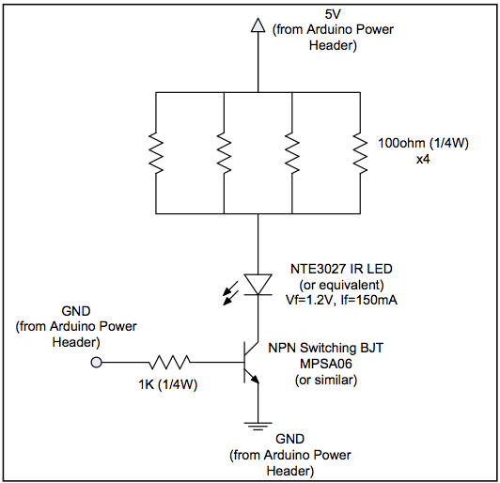
Figure 1: IR Emitter circuit [1]

I will break down and explain each part, but here is the part of the firmware that does the actual work to transmit the bytes as IR signals are as follows (adapted from Moody’s work [2]):
//-------------------info about bits---------------------
----------
#define totallength 22
+18 command
#define channelstart 0
#define commandstart 4
//number of highs/bits 4 channel
//bit where command starts

#define
#define
#define
#define
#define
#define
#define
#define
#define
#define
headerlower 2300
headernom 2550
headerupper 2800
zerolower 300
zeronom 500 //380
zeroupper 650
onelower 800 onenom 1000//850 oneupper 1100
highnom 630
assignments--------------
//doesnt use interrupts so
//lower limit
//nominal
//upper limit
//nominal

//nominal

//---------------------pin
#define TXpin 7
#define RXpin 2 can be anything
#define channellength 4
#define commandlength 18
//---------determined empirically--------------

//----------------------variables----------------------
#define countin 1048576

boolean bit2[totallength]; unsigned long buttonnum; unsigned long x = 0;
unsigned long count = countin; unsigned long buf = 0;

void setup() { Serial.begin(38400); pinMode(RXpin, INPUT); pinMode(TXpin, OUTPUT);
}

void loop() {
// skipped – explained/shown later

}

int SerialReadHexDigit(char digit)
{
byte c = (byte) digit;
if (c >= '0' && c <= '9') { return c - '0';
} else if (c >= 'a' && c <= 'f') { return c - 'a' + 10;
} else if (c >= 'A' && c <= 'F') { return c - 'A' + 10;
} else {

void oscWrite(int pin, int time) {
38khz
for(int i = 0; i < (time / 26) -
//prescaler at 26 for 16mhz, 52 at digitalWrite(pin, HIGH);
//writes at approx
1; i++){
8mhz, ? for 20mhz
}
return -1;
}
// non-hexadecimal digit

void ItoB(unsigned long integer, int length){
//needs bit2[length] Serial.println("ItoB");
for (int i=0; i<length; i++){
if ((integer / power2(length-1-i))==1){ integer-=power2(length-1-i); bit2[i]=1;
}
else bit2[i]=0; Serial.print(bit2[i]);
}
Serial.println();
}
unsigned long power2(int power){
(power)
//gives 2 to the

unsigned long
bitshifting and for (int i=0; integer*=2;
}
integer=1;
pow functions had i<power; i++){
//apparently both
problems
//so I made my own

return integer;
}

void buttonwrite(int txpin, unsigned long integer){
//must be full integer (channel + command)
ItoB(integer, 22); //must
have bit2[22] to hold values oscWrite(txpin, headernom); for(int i=0;i<totallength;i++){
if (bit2[i]==0) delayMicroseconds(zeronom); else delayMicroseconds(onenom); oscWrite(txpin, highnom);
}
delay(205);
}

delayMicroseconds(10); digitalWrite(pin, LOW); delayMicroseconds(10);
}
}

Firmware Part 1 – Constants and Variables

1 | //-------------------info about bits------------
2 | #define totallength 22 //number of highs/bits 4
 | channel +18 command
3 | #define channelstart 0
4 | #define commandstart 4 //bit where command
 | starts
5 | #define channellength 4
6 | #define commandlength 18
7 | //---------determined empirically--------------
8 | #define headerlower 2300 //lower limit
9 | #define headernom 2550 //nominal
10 | #define headerupper 2800 //upper limit
11 | #define zerolower 300
12 | #define zeronom 500 //nominal
13 | #define zeroupper 650
14 | #define onelower 800
15 | #define onenom 1000 //nominal
16 | #define oneupper 1100
17 | #define highnom 630
18 | //---------------------pin assignments--------------
19 | #define TXpin 7
20 | #define RXpin
21 | //----------------------variables-------------------
22 | #define countin 1048576
23
24 | boolean bit2[totallength];
25 | unsigned long buttonnum;
26 | unsigned long x = 0;
27 | unsigned long count = countin;
28 | unsigned long buf = 0;
29

Moody defined several constants in his code, but in this project/application we only need a few of them. That is, in the scope of this project, you can ignore most of those constants, but do pay special attention to the following (highlighted items above):
-­‐ (line 2) #define totallength 22:

- This value is used in the buttonwrite() function.
- It refers to the number of bits in a type 1 iSobot command. Type 0 commands have 30 bits. As you can see, this firmware currently only focuses on type 1 commands. You can make this firmware to support type 0 commands4 as your next/future project.
-­‐ (line 9) #define headernom 2550:
- This value is used in the buttonwrite() function.
- It refers to the 2.5 ms signal (at 38kHz – explained below) that needs to be sent to iSobot as the header signal, indicating that a command is about to be sent.
-­‐ (line 12) #define zeronom 500:
- This value is used in the buttonwrite() function.
- It refers to the gap (logic 0) between bursts (logic 1) in the signal. For logic 0, the signal is preceded by 0.5ms of logic 0, followed by a 0.5-­‐ 0.6ms burst of logic 1.
-­‐ (line 15) #define onenom 1000:
- This value is used in the buttonwrite() function.
- It refers to the gap (logic 0) between bursts (logic 1) in the signal. For a logic 1, the signal is preceded by 1.0ms of logic 0, followed a 0.5-­‐ 0.6ms burst of logic 1.
-­‐ (line 17) #define highnom 630:
- This value is used in the buttonwrite() function.
- It refers to the duration of the bursts of logic 1. This is the original value used by Moody [2] which seems to work fine with my system. Bhutada’s reported using 0.5ms, while profmason [3] probed the signal to be at 0.55ms. You can try different values which may work better.
-­‐ (line 19) #define TXpin 7:
- This value is used in the setup() and loop().
- It refers to the output (i.e. TX) pin of the Arduino board that drives the IR LED.
-­‐ (line 22) #define countin 1048576:
- This value is used in the loop() function.
- It is used as the initial value for the variable:
▪▪ unsigned long count = countin;
- It refers to the value of a 6-­‐digit hex string (220).
- I needed it to convert the hex characters received into the 22-­‐bit command string (in binary).

4 I have not fully confirmed this, but type 0 commands seems to involve manual and individual control over iSobot’s arms and/or walking (http://minkbot.blogspot.com/2009/08/isobot-­‐infrared-­‐remote-­‐protocol-­‐ hack.html)

I will skip the details on the variable declarations, as they are relatively straightforward. The only variables you might want to pay attention to are:
-­‐ unsigned long x = 0;
-­‐ unsigned long count = countin;
-­‐ unsigned long buf = 0;
These variables have type ‘unsigned long’ because they are used to calculate the 22-­‐ bit command string (3 bytes). Regular ‘int’ type only holds up to 2 bytes, while ‘unsigned long’ holds up to 4 bytes. As I mentioned above, the variable ‘count’ is initialized to have the value of the countin constant (line 28).

Firmware Part 2 – setup()
1
2
3
4
5
void setup() { Serial.begin(38400); pinMode(RXpin, INPUT); pinMode(TXpin, OUTPUT);
}

The setup() method along with the loop() method are the core constructs in an Arduino code. They are the absolute minimum methods you must implement.
In the setup method, you define things like: pin assignments, serial port initialization, etc.

In fact, as you can see above, those are exactly the only things we did:
-­‐ (line 2) Serial.begin(38400):
- We initialize communication with the serial port at 38400 baud rate.
-­‐ (line 3) pinMode(RXpin, INPUT);
- Assign pin #2 (see value of the constant RXpin) as input line (we are not using this pin in this project).
-­‐ (line 4) pinMode(TXpin, OUTPUT);
- Assign pin #7 (see value of the constant TXpin) as the output line. In this case, this pin drives the IR LED.

I will explain the loop() method last, after all the other methods are explained. That way, I hope the explanation of the loop method will make more sense.

Firmware Part 3 – SerialReadHexDigit(char digit)
1
2
3
int SerialReadHexDigit(char digit)
{
byte c = (byte) digit;

4 | } | if (c >= '0' && c <= '9') { return c - '0';  } else if (c >= 'a' && c <= 'f') { return c - 'a' + 10;  } else if (c >= 'A' && c <= 'F') { return c - 'A' + 10;  } else {  return -1; // non-hexadecimal digit  }
5
6
7
8
9
10
11
12
13

The SerialReadHexDigit() function takes a ‘digit’ argument in the form of a hexadecimal character (0..9,A..F) – not the actual hexadecimal value. It is important to note that in this system, it was assumed that the software (i.e. my Python code) is sending the command string one hexadecimal digit at a time. This is because the serial port only buffers one byte at a time, so you cannot send the whole command string at once.

However, the hexadecimal digit being sent is represented as an ASCII character. As you can see in Figure 2 below5 the character ‘9’ has decimal value of 57, and character ‘A’ has decimal value of 65. For this reason, we need this method to convert these characters into computable (i.e. decimal) values to construct the actual command string (in binary bits).

5 Source: http://www.asciitable.com/

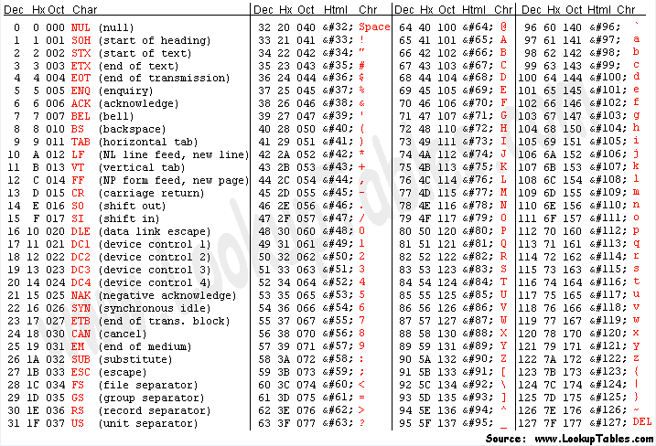
Figure 2: ASCII codes

So, in order to get the actual decimal values of the hexadecimal characters, the SerialReadHexDigit function does the following (pseudo code):

If ‘digit’ is a character in
{‘0’,’1’,’2’,’3’,’4’,’5’,’6’,’7’,’8’,’9’}:
return the ASCII decimal value of ‘digit’ minus ASCII decimal value of 0,
else, if ‘digit’ is a character in
{‘a’,’b’,’c’,’d’,’e’,’f’} (lowercase): return the ASCII decimal value of ‘digit’
minus ASCII decimal value of ‘a’ (lowercase a) plus 10,
else, if ‘digit’ is a character in
{‘A’,’B’,’C’,’D’,’E’,’F’} (uppercase):
return the ASCII decimal value of ‘digit’ minus ASCII decimal value of ‘A’ (uppercase a) plus 10,
else return -1 (other characters are invalid)

The SerialReadHexDigit function can be represented in Table 2:

Table 2: SerialReadHexDigit function
(char) digit | (int) SerialReadHexDigit(digit)
‘0’ | 0
‘1’ | 1
‘2’ | 2
‘3’ | 3
‘4’ | 4
‘5’ | 5
‘6’ | 6
‘7’ | 7
‘8’ | 8
‘9’ | 9
‘a’ or ‘A’ | 10
‘b’ or ‘B’ | 11
‘c’ or ‘C’ | 12
‘d’ or ‘D’ | 13
‘e’ or ‘E’ | 14
‘f’ or ‘F’ | 15

Firmware Part 4 – ItoB(unsigned long integer, int length)

1 | void ItoB(unsigned long integer, int length){  //needs bit2[length]  Serial.println("ItoB"); // for debugging purposes  for (int i=0; i<length; i++){  if ((integer / power2(length-1-i))==1){ integer-=power2(length-1-i); bit2[i]=1;  }  else bit2[i]=0; Serial.print(bit2[i]);  }  Serial.println();  }
2
3
4
5
6
7
8
9
10
11
12
13

The ItoB() (stands for ‘Integer to Binary’) method takes the integer form of the command string, and stores the binary bits into the array bit2. Notice that the array bit2 was declared with length 22 (see the variable declaration line 28).

Firmware Part 5 – power2(int power)

1 | unsigned long power2(int power){  unsigned long integer=1; //apparently both bitshifting and pow functions had problems  for (int i=0; i<power; i++){ //so I made my own integer*=2;  }  return integer;  }
2
3
4
5
6
7

This function takes the argument ‘power’ and calculates/returns 2power .As Moody commented (yes, those comments are his original comments on the code), he wrote this function because the built-­‐in bit shifting and power functions did not suffice.

Firmware Part 6 – buttonwrite(int txpin, unsigned long integer)

1 | void buttonwrite(int txpin, unsigned long integer){  //must be full integer (channel + command)  ItoB(integer, 22); //must have bit2[22] to hold values  oscWrite(txpin, headernom); for(int i=0;i<totallength;i++){  if (bit2[i]==0) delayMicroseconds(zeronom); else delayMicroseconds(onenom); oscWrite(txpin, highnom);  }  delay(205);  }
2
3
4
5
6
7
8
9
10
11

The buttonwrite() method takes the arguments:
-­‐ txpin : the pin number which drives the IR LED
-­‐ integer : the integer value of the command string (3 bytes – hence the ‘unsigned long’ type)

This method essentially does all the iSobot communication protocols. The constants given above already gave some indication of the protocol, but the following image illustrates the protocol (taken from [1]).

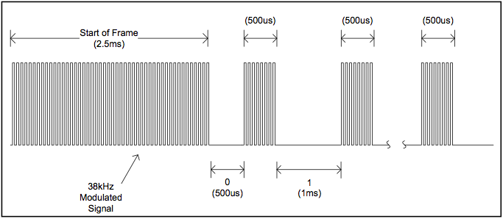
Figure 3: iSobot IR communication protocol

As shown in the illustration, the message must be initiated with the “Start of Frame” signal which lasts for 2.5ms. The message itself is modulated at 38kHz. After the “Start of Frame”, the actual binary bits of the message is then sent as (this is a repeat from above):
-­‐ logic 0 : 0.5ms gap/logic 0 followed by a 0.5ms burst of logic 1.
-­‐ logic 1 : 1.0ms gap/logic 1 followed by a 0.5ms burst of logic 1.

So, the buttonwrite() method performs this protocol as follows:
- (line 3) ItoB(integer,22) : this prepares the command string into an array of binary (i.e. Boolean) bits.
- (line 4) oscWrite(txpin, headernom) : this sends the “Start of Frame” signal.
- (line 5 through 8) send each bit (in the array bit2) according to the protocol of sending logic 0 and 1 above, using the method oscWrite(). Notice, the arguments ‘zeronom’ (line 6) and ‘onenom’ (line 7) are defined in the constants above, and refer to delay for logic 0 (0.5ms) and 1 (1.0ms), respectively. The argument ‘highnom’ (line 8) refers to the duration of the burst of logic 1.
- (line 10) Give a delay of about 0.2ms before the next command can be read.

Firmware Part 7 – oscWrite(int txpin, int time)
1

2
3
4
5
void oscWrite(int pin, int time) {
approx 38khz
for(int i = 0; i < (time / 26) -
//prescaler at 26 for 16mhz, 52 at digitalWrite(pin, HIGH); delayMicroseconds(10);
//writes at
1; i++){
8mhz, ? for 20mhz

6
7
8
9
digitalWrite(pin, LOW);
delayMicroseconds(10);
}
}

This method takes the arguments:
-­‐ pin : the pin number to drive (in this case, to drive the IR LED).
-­‐ time : the burst duration under 38kHz.

The value 26 (line 2) is the prescaler used to make the signal being sent is at 38kHz rate, since we are using a 16MHz clock for the ATmega328 of the Arduino board (Arduino Duemilanove or Uno). If you are using an 8MHz clock, then the value of the prescaler is 52. I had to empirically try different values for the delays between logic 1 and logic 0 for the IR LED (lines 4 and 6). Some values may make the iSobot to not always respond to/execute every single command being sent. I found 10 yields a pretty good result (i.e. all commands are accepted and executed).

Firmware Part 8 – loop()
1
2
3
4
5
6
7
8
9
10
11
12
13
14
15
16
17
18
19
20
21
22
void loop() {
while (Serial.available() > 0){
//Serial control
char switcher= (byte) Serial.read(); if (switcher == '\r') {
Serial.print("Break: "); Serial.println(buf,HEX); buttonwrite(TXpin, buf); buf = 0;
count = countin; delayMicroseconds(300); break;
}
x = SerialReadHexDigit(switcher); x = x * count;
//Serial.println(x,BIN); buf = buf + x;
count = count / 16;
//Serial.print("Buffer: ");
//Serial.println(buf,HEX);
} // end while
}

The loop() method (as previously mentioned) with the setup() method are the two methods at minimum you must implement for an Arduino sketch/program. The loop method is your main method which continuously and repeatedly runs when your Arduino board is connected to a power supply.

Here, in the loop method, the while loop (line 2) will keep collecting input from the serial port as long there is a byte ready at the port (Serial.available() > 0). If there is not any byte ready at the serial port, the loop method will just keep … looping, and doing nothing since there is nothing to be done outside the while loop. However, if there is a series of bytes from the serial port, it will be collected and calculated to construct the command string (line 14 through 18).

The order of the command string being sent from the serial port (i.e. by the iSobot class) is the highest hexadecimal digit to the lowest digit. So, for example: the command string is ['2', '9', 'b', '7', '0', '3', '\r']. Then, the string will be sent per character in order from left to right: ‘2’ then ‘9’ then ‘b’ and so on. Because of this design choice, the decimal value of the command string is calculated from the highest value first. Hence, the multiplier ‘count’ starts from 1048576 (see constant declarations above, line 22), and after each digit, ‘count’ is divided by 16 (line 18) since it is in hexadecimal (4 bits). The total decimal value of the command string is stored in the variable ‘buf’.

The last character ‘\r’ (newline character) indicates the end of the command string. Thus, when the newline character is detected, the command string is assumed to have been constructed, it is then processed and passed to the buttonwrite() method to be transmitted as IR signals (line 8). After the signal has been transmitted, the ‘buf’ and ‘count’ variables are reset, and a new command is ready to be accepted (after a 0.3ms delay).

Lingering Issues

There are a few issues that have not been addressed:
-­‐ There is no programmatic way to tell when iSobot is finished with an action (i.e. there is no method we can call from the iSobot to check when it is done executing one command so we can send the next command). At least, there are no known ways to do that at the time this report was written. If another command is sent, it will immediately be executed, without completing the previous command. This may or may not be a feature or bug, depending on how you design your program around this … behavior. The best I could come up with so far is to manually determine how long it takes to complete an action (if I want the iSobot to complete the action) and give the appropriate time delay in my program before sending the next commands. In other occasion, when I am more concerned about synchronizing the iSobot with

other media (music or video), I will prioritize matching the delays according to the timing on the media rather than waiting for the action to complete.
-­‐ Currently, the goal of this project was to realize the Act 4 of the Portland Robot Theater, which involves synchronizing the robot actions to the ECE 2011 Graduation ceremony music video, played by Jay Penev and the ECE faculty and staff. However, there is currently no direct/programmatic synchronization between the robot actions/commands and the music/video. The video was launched from a Python program as a separate process, and following that, the sequence of actions for the iSobots is executed. The timing of the actions for the iSobots was determined manually by hand. Needless to say, the synchronization is currently poor.
-­‐ The IR emitter is currently tethered to a PC. This makes it very difficult to have a good theater because the emitter must be placed somewhere where it has direct view of the iSobots’ IR receiver, while at the same time tethered via a USB cable to a laptop/desktop. It occurred several times during testing/demo that the iSobot is in some position which blocks the IR line-­‐of-­‐ sight, making it not executing several commands.
-­‐ Controlling iSobot in two different modes. The iSobot can operate in either Mode A or Mode B. The mode is selected by a switching a physical switch on the back of the iSobot. There is currently no way of changing modes on-­‐the-­‐ fly (i.e. via a command). When multiple iSobots are on the same mode – let’s say there are two iSobots and both are on Mode B, a command for Mode B sent to the iSobots will be executed by both iSobots simultaneously. It creates an interesting illusion of synchronization. However, we may want each iSobot to do different actions executed at the same time to make for a more interesting performance. For this, the iSobots need to be in different modes. Since we only have one IR emitter, we cannot do this currently.
Moreover, it probably will involve a more complex program – maybe one that requires using threading for simultaneous executions.
-­‐ The current system does not support command Type 0 (control of individual arms, directional walking).

Conclusions and Future Work

I have created a Python class called iSobot that would (hopefully) make it easier for the next students and future projects to quickly work with the iSobot to do their every whim (or most of it). I also provided a more detailed explanation on the Arduino program for the IR emitter and the iSobot command protocol. I provided the source code both for the Python class and the Arduino program in Appendix A and B, respectively. Additionally, a Python program I wrote as a preliminary version of Act 4 of the Robot Theater project is given in Appendix C.

There are still a number of lingering issues that have been addressed yet. I would like to see future works that build on top of this report address: support for command Type 0, a more elegant solution to timing for command execution, and individual/separate controls for multiple iSobots.

References:
[1] Bhutada, Aditya, 2010 ‘Universal Event and Motion Editor for Robots‟ Theatre’, MS thesis, Portland State University, Portland, OR.
[2] Moody, Miles, 2009, I-­‐Sobot hacked or Pro Mini shield, viewed 4 April 2012,
<http://www.arduino.cc/cgi-­‐bin/yabb2/YaBB.pl?num=1237771631>. [3] Mason, Martin, 2008, ISOBot IR hacking, viewed 4 April 2012,
<http://profmason.com/?p=627>.
[4] MichWorks, 2009, iSobot Infrared Remote Protocol Hack, viewed 4 April 2012,
<http://minkbot.blogspot.com/2009/08/isobot-­‐infrared-­‐remote-­‐protocol-­‐ hack.html>

Appendix A – isobot.py

import serial,time,re,sys class iSobot:
# iSobot Command byte list
# Source: http:#minkbot.blogspot.com/2009/08/isobot- infrared-remote-protocol-hack.html
#

# Standard commands CMD_RC = 0x07 CMD_PM = 0x08 CMD_SA = 0x09 CMD_VC = 0x0a
CMD_1P = 0x13 # left punch CMD_2P = 0x14 # right punch
CMD_3P = 0x15 # left side whack (arm outwards) CMD_4P = 0x16 # right side whack
CMD_11P = 0x17 # left + right punch CMD_12P = 0x18 # right + left punch CMD_13P = 0x19 # left up-down chop CMD_14P = 0x1a # right up-down chop CMD_21P = 0x1b # both up-down chop CMD_22P = 0x1c # both down-up chop
CMD_23P = 0x1d # right + left punch, both up-down chop, both whack
CMD_24P = 0x1e # look left, up-down chop CMD_31P = 0x1f # look right, up-down chop CMD_32P = 0x20 # "c'mon, snap out of it" slap CMD_34P = 0x21 # both whack
CMD_1K = 0x22 # left wide kick CMD_2K = 0x23 # right wide kick CMD_3K = 0x24 # left kick CMD_4K = 0x25 # right kick CMD_11K = 0x26 # left side kick CMD_12K = 0x27 # right side kick CMD_13K = 0x28 # left back kick CMD_14K = 0x29 # right back kick
CMD_31K = 0x2a # right high side kick CMD_42K = 0x2b # right soccer/low kick CMD_21K = 0x2c # left + right high side kick
CMD_22K = 0x2d # right + left soccer/low kick
CMD_23K = 0x2e # combo kick low-left, high-side-right,
left

CMD_24K | = | 0x2f | # | another left kick
CMD_31K | = | 0x30 | # | right high kick
CMD_34K | = | 0x31 | # | split
CMD_1G = |  | 0x32 | # | Block! "whoa buddy"
CMD_2G = |  | 0x33 | # | right arm block
CMD_3G = |  | 0x34 | #
CMD_4G = |  | 0x35 | # | both arms block
CMD_11G | = | 0x36 | # | dodge right (move left)
CMD_12G | = | 0x37 | # | dodge left (move right)
CMD_13G | = | 0x38 | # | headbutt
CMD_14G | = | 0x39 | # | right arm to face
CMD_21G | = | 0x3a | # | taunt1
CMD_22G | = | 0x3b | # | hit & down
CMD_23G | = | 0x3c | # | dodge right, left, block | left, head,
fall down
CMD_A = 0x3d CMD_B = 0x3e
CMD_1A = 0x3f # "Roger!" raise right arm CMD_2A = 0x40 # weird gesture
CMD_2A = 0x41 # "All your base are belong to isobot" CMD_3A = 0x42 # "absolutely not!" flaps both arms CMD_4A = 0x43 # bow/crouch? and get back up
CMD_11A = 0x44 # "Good morning!" raise both arms, stand on left foot
CMD_12A = 0x45 # "Greetings I come in peace" wave right arm
CMD_13A = 0x46 # "Y'all come back now, you hear!"
CMD_14A = 0x47 # "Wassap!?" opens both arms sideways over and down
CMD_21A = 0x48 # "Greetings human" raise left arm and
bow
CMD_22A = 0x49 # "It's an honor to meet you!" bow and shake right hand
CMD_23A = 0x4a # "Bye bye" CMD_31A = 0x4b # "Bon voyage!"
CMD_32A = 0x4c # *clap* *clap* "Thanks! I'll be here all week" raise right arm
CMD_33A = 0x4d # "T-t-that's all robots!" raise left arm, stand on left foot
CMD_41A = 0x4e # "Domo arigato from isobot-o" CMD_42A = 0x4f
CMD_43A = 0x50 CMD_111A = 0x51 CMD_222A = 0x52 CMD_333A = 0x53
CMD_11B = 0x54 # Walk forward + "Give me a bear hug" CMD_12B = 0x55

CMD_13B = 0x56 CMD_14B = 0x57 CMD_31B = 0x58 CMD_22B = 0x59 CMD_23B = 0x5a CMD_24B = 0x5b CMD_31B = 0x5c
CMD_32B = 0x5d # "woe is me ... what to do ... what to do" bow, shakes head
CMD_33B = 0x5e # "No no .... not again. ... No no" CMD_234B = 0x5f # "Oh, I can't believe I did that" CMD_41B = 0x60 # "I throw myself into a mercy" (?) CMD_42B = 0x61 # "Oh, like a dagger through my heart" CMD_43B = 0x62 # Same as 44B but no voice
CMD_44B = 0x63 # "Ouch, that hurts!" CMD_112A = 0x65 # points left "wahoo" CMD_113A = 0x66 # pose northwest "hoo-ah!" CMD_114A = 0x67 # points left "kapwingg" CMD_124A = 0x6b # "iz nice. you like?"
CMD_131A = 0x6c # both arm wave left right left CMD_132A = 0x6d # drunk
CMD_113B = 0x6e # "no please make it stop." "please i can't take it anymore" "no no" lying down and get up
CMD_114B = 0x6f # "yippe yippe" 3 times, goal post arms CMD_121B = 0x70 # "ho ho ho ... <something-something>
isobot"
CMD_122B = 0x71 # "yeehaaw" both arm wave left right CMD_123B = 0x72
CMD_124B = 0x73 # stand on one foot, goal post arms, "wow that's amazing"
CMD_131B = 0x74 # bow, arms over head and down CMD_132B = 0x75
CMD_133B = 0x76 CMD_134B = 0x77 CMD_141A = 0x78
CMD_143A = 0x79 # sit cross legged CMD_144A = 0x7b # ... owl?
CMD_211B = 0x7c
CMD_212B = 0x7d # "Ahh, let me get comfortable. I'm too sexy for my servos" lie down, flips over, gets up
CMD_213B = 0x7e
CMD_221B = 0x80 # balancing act + bleeps (+) CMD_222B = 0x81 # looks like a push up CMD_223B = 0x82
CMD_224B = 0x83 # "You can count on me" CMD_232B = 0x85
CMD_233B = 0x86

CMD_A =
times
CMD_B = CMD_AB = CMD_AAA CMD_BBB
0x8a
# flip forward back forward about 3
0x8b
0x8c
=
=
CMD_BAB
CMD_ABB CMD_BBA CMD_ABA CMD_ABAB CMD_AAAA CMD_FWRD CMD_BWRD CMD_FWLT CMD_FWRT CMD_LEFT CMD_RGHT CMD_BKLT CMD_BKRT CMD_411A CMD_412A CMD_413A CMD_444B CMD_444A
=
=
=
=
0x8d
0x8e 0x8f 0x95
0x97
0x98
#
#
#
#
"BANZAI"
chicken dancing
3 times
(+)
=
=
=
=
=
=
=
=
CMD_241B = 0x88
CMD_242B = 0x89
# headstand

giant robot motion
= 0x99
= 0x9a
= 0xb7
= 0xb8
= 0xb9
= 0xba
= 0xbb
= 0xbc
= 0xbd
= 0xbe
= 0xc7
= 0xc8
= 0xc9
= 0xca
= 0xcb # nothing CMD_LVSoff = 0xd3
CMD_HP =
CMD_NOIMP CMD_END = MSG_NOIMP MSG_NOIMP MSG_RUP MSG_RDW MSG_RRT MSG_RLT MSG_LUP MSG_LDW MSG_LRT MSG_LLT
0xd5
= 0xd6 0xd7
= 0x848080
= 0x848080 0x878280
0x808280
0x8480f0
0x848080
0x84f080
0x841080
0xec8080 0x0c8080
# Bonus Commands
CMD_TURNON = 0x01 CMD_ACTIVATED = 0x02 CMD_READY = 0x03 CMD_RC_CONFIRM = 0x04

same
CMD_RC_PROMPT = 0x05 CMD_MODE_PROMPT = 0x06
CMD_IDLE_PROMPT = 0x0B # = 0x0C,= 0x0D,= 0x0E all the

CMD_HUMMING_PROMPT = 0x0F CMD_COUGH_PROMPT = 0x10 CMD_TIRED_PROMPT = 0x11 CMD_SLEEP_PROMPT = 0x12 CMD_FART = 0x40 # 2A CMD_SHOOT_RIGHT = 0x64 CMD_SHOOT_RIGHT2 = 0x68 CMD_SHOOT2 = 0x69 CMD_BEEP = 0x6a
CMD_BANZAI = 0x7F # "TAKARA TOMY" CMD_CHEER1 = 0x90
CMD_CHEER2 = 0x91 CMD_DOG = 0x92 CMD_CAR = 0x93 CMD_EAGLE = 0x94 CMD_ROOSTER = 0x95 CMD_GORILLA = 0x96 CMD_LOOKOUT = 0xA1
CMD_STORY1 = 0xA2 # knight and princess CMD_STORY2 = 0xA3 # ready to start day CMD_GREET1 = 0xA4 # good morning CMD_GREET2 = 0xA5 # do somthing fun CMD_POOP = 0xA6 # poops his pants CMD_GOOUT = 0xA7 # ready to go out dancing
CMD_HIBUDDY = 0xA8 # .. bring a round of drinks CMD_INTRODUCTION = 0xA9
CMD_ATYOURSERVICE = 0xAA CMD_SMELLS = 0xAB CMD_THATWASCLOSE = 0xAC CMD_WANNAPICEOFME = 0xAD CMD_RUNFORYOURLIFE = 0xAE CMD_TONEWTODIE = 0xAF
# 0xB0 - nothing? CMD_SWANLAKE = 0xB1 CMD_DISCO = 0xB2 CMD_MOONWALK = 0xB3 CMD_REPEAT_PROMPT = 0xB4 CMD_REPEAT_PROMPT2 = 0xB5 CMD_REPEAT_PROMPT3 = 0xB6
# 0xB7-= 0xC4 single steps in different directions CMD_HEADSMASH = 0xC5
CMD_HEADHIT = 0xC6
# 0xCC-= 0xD2 - unknown (use param?)

# after exercising one of these I am getting only beeps instead of voice/sounds
# (looks like a tool to synchronize sound with moves) CMD_HIBEEP = 0xD3
# = 0xD4 - unknown (use param?) CMD_BEND_BACK = 0xD8 # same untill = 0xDB
CMD_SQUAT = 0xDB # also = 0xDC # doesn't work (both) CMD_BEND_FORWARD = 0xDD
CMD_HEAD_LEFT_60 = 0xDE CMD_HEAD_LEFT_45 = 0xDF CMD_HEAD_LEFT_30 = 0xE0 CMD_HEAD_RIGHT_30 = 0xE1 CMD_HEAD_RIGHT_45 = 0xE2 CMD_HEAD_RIGHT_60 = 0xE3
# seems identical to A & B getups CMD_GETUP_BELLY = 0xE4 CMD_GETUP_BACK = 0xE5
# E6 unknown CMD_HEAD_SCAN_AND_BEND = 0xE7 CMD_ARM_TEST = 0xE8 CMD_FALL_AND_LEG_TEST = 0xE9 CMD_THANKYOUSIR = 0xEA CMD_ILOVEYOU_SHORT = 0xEB CMD_3BEEPS = 0xEC CMD_FALL_DEAD = 0xED CMD_3BEEPS_AND_SLIDE = 0xEE
# EF-FF unknown serialPort = 0
#
# Initialize class
#
def init (self, port='/dev/cu.usbserial-A8008pQc', baud=38400, databit=8, parity=None):
print "Initializing iSobot!" self._port = port
#port='/dev/tty.usbserial-A8008pQc' # Mac default
USB
#port='/dev/tty.usbserial-A9007KX5' # The other Mac
USB port
try:
self._serialPort = serial.Serial(port, baud,
bytesize=databit, parity='N') #UNCOMMENT TO RUN #UNCOMMENT TO RUN
self._serialPort.open()
if self._serialPort.isOpen():

print "Serial port is opened."
except Exception as e: # Catch exception in case serial connection fails
print "Unable to connect to serial port." print e
sys.exit(1)

#
# Construct command string
# Returns integer. To use: convert returned value using hex() then process as array of characters excluding '0x'
# How to construct isobot command string:
## command = [channel (1 bit)]:[type (2 bits)]:[checksum (3 bits)]:[commandbyte1 (8
bits)]:[commandbyte2 (8 bits)]:[params (8 bits)]
## channel: 0 -> Mode A, 1 -> Mode B
## type: 00 -> Type 0, 01 -> Type 1
## checksum: How to calculate:
### 1. add the header bits (channel, type, and checksum). For this, just give checksum 0x00 in the calculation.
### After the calculation, this value will be updated.
### 2. Do sum (logical OR) on the sum bits, 3 bits at a time. (see below: implemented as 3-bits right-shift)
### 3. Return the last three bits of this value as the checksum.
### 4. Add the checksum to the header bits (just do normal +)
## commandbyte1: see isobot.py for the command bytes
## commandbyte2: see isobot.py for the command bytes.
Not used in command Type 1
## params: ALWAYS 0x03 (don't know what it is for)
# Example:
## For Mode A (channel bit: 0), Type 1 (type bits: 01), checksum (bits: 000):
### header_bits = channel:type:checksum
### = 0:01:000
### Notice this is a 6-bits string. You must look at it as a byte.
### header_bits (as byte, in hex) = 00001000 = 0x08
## For Mode B (channel bit: 1), Type 1 (type bits: 01), checksum (bits: 000):
### header_bits = 1:01:000
### header_bits (as byte, in hex) = 00101000 = 0x28
## Walk forward byte: CMD_FWRD = 0xb7 = 10110111 (see

isobot.py)
## Params: 0x03 = 00000011
## command string in Mode A, Type 1 (checksum not calculated yet): [header_bits]:[walkforwardbyte]:[params] = [00101000]:[10110111]:[00000011]
## Caculate checksum:
### sum = 0x28 + 0xb7 + 0x03
### = 226 = 0xe2 = 11100010
### take and sum 3 bits at a time (i.e. scan 3 bits at a time from right to left)
### 010 + 100 + 011 (padded with zero) = (1)001
### The total is actually 9 (0x09) but we only use the last three bits. So checksum = 0x01
## Add the checksum to the header bits:
### 0x28 + 0x01 = 0x29 = 00101001
## The command string becomes: [00101000]:[10110111]:[00000011] = 0x29b703

def makeCmd(self, ch, type, cmd1, cmd2=0): param = 0x03

# Different header bytes depending on channel and type. See: http://minkbot.blogspot.com/2009/08/isobot- infrared-remote-protocol-hack.html
if ch==0 and type==0: hdr = 0x00
elif ch==1 and type==0: hdr = 0x20
elif ch==0 and type==1: hdr = 0x08
elif ch==1 and type==1: hdr = 0x28
else:
return -1

# Calculate sum of command string. Checksum: 000 if type==0:
sum = hdr + cmd1 + cmd2 + param # For command type 0 (individual/manual arm control?)
elif type==1:
sum = hdr + cmd1 + param # For command type 1 (most commonly used)
else:
return -1

# Calculate checksum
chksum = ((sum & 7) + ((sum >> 3) & 7) + ((sum >>

# byte
6) & 7) &7)
hdrsum = hdr + chksum
# Construct the hex
if type==0:
return hex(((hdrsum (cmd2 << 8) + (param)))
elif type==1:
<< 32) + (cmd1 << 16) +
string for type 0 commands
return hex(((hdrsum << 16) + (cmd1 << 8) +
(param))) # byte string for type 1 commands else:
return -1

#
# Send command to serial port (Arduino + IR - Aditya's
box)
#
def sendCmd(self, cmd):
#if serialPort.isOpen(): try:
print "port is open"
print "Sending command...\n" for c in cmd:
print "hex: %s" % c self._serialPort.write(c) #UNCOMMENT TO RUN

#serialPort.close() print "------------------\n"
#else:
except serial.SerialException:
print "Port is not open/available"
#serialPort.close()

#
# Repeat sending command
# Default # of tries: 300. Some actions (e.g. Walk) require the command to be sent for a period of time.
# e.g. sending the Walk FWRD command once, the robot will accept the command but not move forward
def repeatCmd(self, cmd, rep=300): for i in range(rep):
print "Tx %d: " % i self.sendCmd(cmd) time.sleep(0.5)

#
# Format the hex string

#
# Shorthand function for lazy people (like
#
def isobotDoType1(self, action, channel=0, try:
me)
repeat=3):
### Management
#
# Close serial
#
functions ###
port
#
def formatCmd(self, cmd):
# Remove leading 0x in hex string:
# http://stackoverflow.com/questions/5197959/how- do-i-remove-hex-values-in-a-python-string-with-regular- expressions
c = re.sub(r'0x','',cmd)

# The string must be 6 digits long. Check; if not, add with a leading 0 (assuming the command is type 1 and can only vary
# between 5 or 6 characters if len(c) < 6:
c = c.zfill(6)

c = c + '\r'
print "Command string: %s" % list(c)
# Return the string as a list of characters:
#
http://groups.google.com/group/comp.lang.python/browse_thre ad/thread/6543299e955388e2?pli=1
return list(c) # Must add '\r' at the end of each
string

self.repeatCmd(self.formatCmd(self.makeCmd(channel,1,action
)),repeat)
return 0
except Exception as e:
print "Blargh! Command failed!" print e
return 1

def disconnect(self):
print "Closing serial port ..." try:
self._serialPort.close() print "Port is closed."

return 0
except Exception as e:
print "Unable to close port." print e
return 1

#
# Open serial port
#
def connect(self, port, baud=38400, databit=8, par='N'):
if port == '':
print "No port supplied. Will use previously
used port."
port = self._port
try:
print "Connecting to port ... %s" % port self._serialPort = serial.Serial(port, baud,
bytesize=databit, parity=par)
self._serialPort.open()
if self._serialPort.isOpen(): print "Serial port is opened." return 0
except Exception as e:
print "Unable to connect to serial port." print e
sys.exit(1)

Appendix B – isobotIR.ino

//-------------------info about bits-----------------------
--------
#define totallength 22 //number of highs/bits 4 channel +18 command
#define channelstart 0
#define commandstart 4 //bit where command starts
#define channellength 4
#define commandlength 18
//---------determined empirically--------------
#define headerlower 2300 //lower limit
#define headernom 2550 //nominal
#define headerupper 2800 //upper limit
#define zerolower 300
#define zeronom 500 //380 //nominal
#define zeroupper 650
#define onelower 800
#define onenom 1000//850 //nominal
#define oneupper 1100
#define highnom 630
//---------------------pin assignments--------------
#define TXpin 7
#define RXpin 2 //doesnt use interrupts so can be anything
//----------------------variables----------------------
#define countin 1048576

boolean bit2[totallength]; unsigned long buttonnum; char msg = ' ';
unsigned long x = 0;
unsigned long count = countin; unsigned long buf = 0;

void setup() { Serial.begin(38400); pinMode(RXpin, INPUT); pinMode(TXpin, OUTPUT);
}

void loop() {
while (Serial.available() > 0){ //Serial control
//msg = Serial.read()
char switcher= (byte) Serial.read(); if (switcher == '\r') {

}
-1; // non-hexadecimal character
Serial.print("Break: ");
Serial.println(buf,HEX); buttonwrite(TXpin, buf); buf = 0;
count = countin; delayMicroseconds(300); break;
}
x = SerialReadHexDigit(switcher);

x = x * count;
//Serial.println(x,BIN); buf = buf + x;
count = count / 16;
//Serial.print("Buffer: ");
//Serial.println(buf,HEX);

} // end while

}

int SerialReadHexDigit(char digit)
{
//byte c = WaitAndRead(); byte c = (byte) digit;
if (c >= '0' && c <= '9') { return c - '0';
}

}
else if
return else if return
else { return
(c >= 'a' && c <= 'f') {
c - 'a' + 10;
(c >= 'A' && c <= 'F') { c - 'A' + 10;

}

}

void ItoB(unsigned long integer, int length){
//needs bit2[length] Serial.println("ItoB");
for (int i=0; i<length; i++){
if ((integer / power2(length-1-i))==1){ integer-=power2(length-1-i); bit2[i]=1;
}
else bit2[i]=0;

Serial.print(bit2[i]);
}
Serial.println();
}

unsigned long power2(int power){ (power)
//gives 2 to the
unsigned long
bitshifting and for (int i=0; integer*=2;
}
integer=1;
pow functions had i<power; i++){
//apparently both
problems
//so I made my own
return integer;
}

void buttonwrite(int txpin, unsigned long integer){
//must be full integer (channel + command)
ItoB(integer, 22); //must
have bit2[22] to hold values oscWrite(txpin, headernom); for(int i=0;i<totallength;i++){
if (bit2[i]==0) delayMicroseconds(zeronom); else delayMicroseconds(onenom); oscWrite(txpin, highnom);
}
delay(205);
}
void oscWrite(int pin, int time) {
approx 38khz
for(int i = 0; i < (time / 26) -
//prescaler at 26 for 16mhz, 52 at digitalWrite(pin, HIGH); delayMicroseconds(10); digitalWrite(pin, LOW); delayMicroseconds(10);
}
}
//writes at
1; i++){
8mhz, ? for 20mhz

Appendix C – Preliminary Act 4 program

import serial, time
import subprocess, isobot, threading

#
# the iSobot sequence will be running as a separate thread
#
class isobotThread( threading.Thread ): def run(self):
isoport = '/dev/tty.usbserial-A8008pQc'

isoport
print "Connecting to isobot on port: %s ..." % bot = isobot.iSobot(isoport, 38400)

bot.isobotDoType1(bot.CMD_RC,1,1) # for some reason, the first command always fail/ignored
#for i in range(10000):
# if i > 9000:
# continue
time.sleep(8) # careful
with the delays
bot.isobotDoType1(bot.CMD_3P,1,1) time.sleep(2)
#bot.isobotDoType1(bot.CMD_11G,0,1)
#time.sleep(0.5) bot.isobotDoType1(bot.CMD_11G,1,1) time.sleep(3)
#bot.isobotDoType1(bot.CMD_12G,1,1)
#time.sleep(3) bot.isobotDoType1(bot.CMD_FWRT,1,5) time.sleep(0.5) bot.isobotDoType1(bot.CMD_FWRT,1,5) time.sleep(2) bot.isobotDoType1(bot.CMD_BKLT,1,4) time.sleep(0.5) bot.isobotDoType1(bot.CMD_BKLT,1,5) time.sleep(2)
#bot.isobotDoType1(bot.CMD_11G,1,1)
#time.sleep(3) bot.isobotDoType1(bot.CMD_12G,1,1) time.sleep(3) bot.isobotDoType1(bot.CMD_FWLT,1,4) time.sleep(0.5) bot.isobotDoType1(bot.CMD_FWLT,1,5) time.sleep(2)

#bot.isobotDoType1(bot.CMD_BKLT,1,4)
#time.sleep(0.5) bot.isobotDoType1(bot.CMD_BKRT,1,4) time.sleep(2)
#bot.isobotDoType1(bot.CMD_FWRT,1,4)
#time.sleep(0.5) bot.isobotDoType1(bot.CMD_FWRT,1,5) time.sleep(2)
#bot.isobotDoType1(bot.CMD_BKLT,1,4)
#time.sleep(2) bot.isobotDoType1(bot.CMD_11G,1,1) time.sleep(3)
#bot.isobotDoType1(bot.CMD_12G,1,1)
#time.sleep(3) bot.isobotDoType1(bot.CMD_21K,1,1) time.sleep(3) bot.isobotDoType1(bot.CMD_4G,1,1) time.sleep(2)
#bot.isobotDoType1(bot.CMD_11G,1,1)
#time.sleep(3) bot.isobotDoType1(bot.CMD_12G,1,1) time.sleep(3)
#bot.isobotDoType1(bot.CMD_FWRT,1,4)
#time.sleep(0.5) bot.isobotDoType1(bot.CMD_FWLT,1,5) time.sleep(2) bot.isobotDoType1(bot.CMD_BKRT,1,4) time.sleep(2)
#bot.isobotDoType1(bot.CMD_32B,1,1)
#time.sleep(0.5) bot.isobotDoType1(bot.CMD_12G,1,1) time.sleep(3) bot.isobotDoType1(bot.CMD_FWRT,1,4) time.sleep(0.5) bot.isobotDoType1(bot.CMD_FWLT,1,5) time.sleep(2)
#bot.isobotDoType1(bot.CMD_BKLT,0,4)
#time.sleep(0.5) bot.isobotDoType1(bot.CMD_BKRT,1,4) time.sleep(2)
#bot.isobotDoType1(bot.CMD_11G,0,1)
#time.sleep(0.5) bot.isobotDoType1(bot.CMD_11G,1,1) time.sleep(3)
#bot.isobotDoType1(bot.CMD_12G,1,1)
#time.sleep(3) bot.isobotDoType1(bot.CMD_22K,1,1)

time.sleep(3) bot.isobotDoType1(bot.CMD_1G,1,1) time.sleep(2)
#bot.isobotDoType1(bot.CMD_FWRT,1,4)
#time.sleep(0.5) bot.isobotDoType1(bot.CMD_FWRT,1,5) time.sleep(2)
#bot.isobotDoType1(bot.CMD_BKLT,0,4)
#time.sleep(0.5)

bot.isobotDoType1(bot.CMD_BKLT,1,4) time.sleep(3) bot.isobotDoType1(bot.CMD_FWRT,1,4) time.sleep(3) bot.isobotDoType1(bot.CMD_FWRT,1,5) time.sleep(3)
#bot.isobotDoType1(bot.CMD_BKLT,1,4)
#time.sleep(0.5)

bot.isobotDoType1(bot.CMD_BKLT,1,4) time.sleep(2) bot.isobotDoType1(bot.CMD_32B,1,1) time.sleep(2)
#bot.isobotDoType1(bot.CMD_11G,0,1)
#time.sleep(0.5) bot.isobotDoType1(bot.CMD_11G,1,1) time.sleep(3) bot.isobotDoType1(bot.CMD_12G,1,1) time.sleep(3) bot.isobotDoType1(bot.CMD_21K,1,1) time.sleep(2) bot.isobotDoType1(bot.CMD_1G,1,1) time.sleep(2) bot.isobotDoType1(bot.CMD_11G,1,1) time.sleep(3)
#bot.isobotDoType1(bot.CMD_12G,0,1)
#time.sleep(0.5) bot.isobotDoType1(bot.CMD_12G,1,1) time.sleep(3) bot.isobotDoType1(bot.CMD_22K,1,1) time.sleep(3) bot.isobotDoType1(bot.CMD_32A,1,1) time.sleep(10)

port = '/dev/tty.usbserial-A9007KX5' try:
print "Connecting to port: %s ..." % port

# Wait a few seconds.
robots play at the same time
# as the music in the time.sleep(8)
--
everybody strumming"
arduino = serial.Serial(port, 9600) # this is for a
second Arduino board that controls activation of two Halloween robots (Appendix D).

except:
print "Failed connecting to serial port", port

try:
if arduino.isOpen():
# Play the video (using VLC) vlc =
subprocess.Popen(["/Applications/VLC.app/Contents/MacOS/VLC ", "ecegraduation.mov"])
if vlc: print "VLC on!"

# Start the isobot thread isobotThread().start()
Adjust this to make the
video starts

print "Song starts arduino.write('C') print "Writing C" arduino.flush() time.sleep(7)
print "c'mon y'all
Greenwood's in the band oh
arduino.write('C') print "Writing C" arduino.flush() time.sleep(7)
let's clap some hands -
yeah!"
even
print "Strumming ..."
arduino.write('C') print "Writing C" arduino.flush() time.sleep(7)

print "Rockin out with famous names, Brano, Holtzmann and McNames oh yeah!"
arduino.write('A') print "Writing A"

print "We're gonna have a bash with Perkowski,
Daasch oh yeah!"
perokwski
on
arduino.flush()
time.sleep(7)

print "Strumming ..." arduino.write('A') print "Writing A" arduino.flush() time.sleep(7)
and
Hall

arduino.write('B') # Mcnames off, print "Writing B" arduino.flush()
time.sleep(7)
print "Strumming ..."
arduino.write('B') # both on print "Writing B" arduino.flush()
time.sleep(7)
print "We might get serious ..."
arduino.write('B') # Mcnames off, print "Writing B" arduino.flush()
time.sleep(7)
perokwski
on
print "Strumming ..."
arduino.write('B') # both on print "Writing B" arduino.flush() time.sleep(7)

print "Remember the first time you failed that class ... digital circuit with Mark Faust oh yeah!"
arduino.write('C') print "Writing C" arduino.flush() time.sleep(7)

print "Strumming ..." arduino.write('C') print "Writing C" arduino.flush() time.sleep(7)

of you
print "Thank you all
we're gonna miss..." arduino.write('B') print "Writing B" time.sleep(7)
for being you now let's go to
print "We couldn't be anymore proud, to have
Lendaris here with us ...Tymerski, Teuscher, Sutherland ... yadda yadda having fun oh yeah!"
arduino.write('A') print "Writing A" time.sleep(7) arduino.write('A') time.sleep(1) arduino.write('B') time.sleep(7) arduino.flush()

print "Strumming ..." arduino.write('B') print "Writing B" arduino.flush() time.sleep(7)
scream
print "Some of you ...makes
WHY WHY!"
arduino.write('C') print "Writing C" arduino.flush() time.sleep(7)
you pull
your hair and
print "Strumming ..."
arduino.write('C') print "Writing C" arduino.flush() time.sleep(7)
print "with the help
arduino.write('C') print "Writing C" arduino.flush() time.sleep(7)
of the
lovely staff ..."
for being a part of this all

print "Thank you all the barbecue right there"
arduino.write('B') time.sleep(1)

arduino.write('A')
time.sleep(7) arduino.write('A') time.sleep(10) arduino.flush() arduino.close()
vlc.kill()
# kill the vlc subprocess
print
except:
print "Failed to send!"

Appendix D – Program of 2nd Arduino to control Halloween robots in Act 4
halloween1 = 11;
halloween2 = 13; msg = ' ';
setup() {
initialize the digital pin as an output. Pin 13 has an LED connected on
most
Arduino
boards:
*Note: I apologize for the dirty code here.
int
int int int int int char void
//
//
bear1Pin1
bear1Pin2 witchPin1 witchPin2
= 8;
= 9;
= 2;
= 3;
/*
Controls the dancing puppets
*/

pinMode(bear1Pin1, OUTPUT);
pinMode(bear1Pin2, OUTPUT); pinMode(witchPin1, OUTPUT); pinMode(witchPin2, OUTPUT); pinMode(halloween1, OUTPUT); pinMode(halloween2, OUTPUT); digitalWrite(halloween1, HIGH); digitalWrite(halloween2, HIGH); Serial.begin(9600); Serial.print("Program init!\n");
}

void loop() {

while (Serial.available() > 0) { msg = Serial.read(); Serial.println(msg);
}

if (msg == 'A') {
//halloweenToggle(halloween1); Serial.println("halloween1 toggled!");

halloweenToggle(halloween1);
//delay(6000);
//halloweenToggle(halloween1);
//delay(6000);

/* original code
digitalWrite(13, delay(2000); digitalWrite(13,
LOW);
// set the LED on
HIGH);
Serial.println("pin 13
delay(5000);
// wait
// set high");
// wait
for
the
a second
LED off
for
a
digitalWrite(13,
delay(2000); digitalWrite(13, delay(2000);
LOW);
// set the LED
// wait for a
HIGH);
// set the
LED
second
on sec
on
digitalWrite(9,
delay(5000); digitalWrite(9, delay(5000); digitalWrite(8, delay(2000); digitalWrite(8, delay(2000);
*/
LOW); // Bear
on
HIGH);
LOW); // Bear
off
HIGH);
} else if (msg == 'B') {
halloweenToggle(halloween2); Serial.print("halloween2 toggled!\n");
} else if (msg == 'C') { halloweenToggle(halloween1); Serial.print("halloween1 toggled!\n"); delay(500); halloweenToggle(halloween2); Serial.print("halloween2 toggled!\n");

}
//Serial.println("hello");
//witchOn();
//delay(5000);
//witchOff();

}

void bear1On() { digitalWrite(bear1Pin1, LOW); digitalWrite(bear1Pin2, HIGH); delay(1000);
bear1Idle();
}

void bear1Off() {

digitalWrite(bear1Pin1, HIGH); digitalWrite(bear1Pin2, LOW); delay(1000);
bear1Idle();
}

void bear1Idle() { digitalWrite(bear1Pin1, HIGH); digitalWrite(bear1Pin2, HIGH);
}

void witchOn() { digitalWrite(witchPin1, LOW);
}

void witchOff() { digitalWrite(witchPin1, HIGH);
}

void halloweenToggle(int id) { digitalWrite(id, HIGH); delay(500);
digitalWrite(id, LOW);
}

Latest update by Waleed Alhaddad and Saad Alaskar on 6/13/16

On week 9, Waleed and Saad were assigned to the Isobot robot where we were assigned to re-demo the isobot. We had to go through a bunch of previous term documentation for Isobot in order to figure out how to control these robots and how they do work. We picked Mathias Sunardi report as it was the clearest report to us and also he used python to control the robot which we were familiar with it. Reading through the documentation probably took us around 10 hours of time in order to find, read through all the documentation we found, and understand the code that was in the robots. We faced big obstacle where both documentations didn’t have proper links or the writer didn’t upload all the codes in the report to the github also the two reports used two different methods which created a big confusion. We had to rewrite all the codes that we needed to be able to use it as we cannot simply copy it from the report as the layout of the code will be different and that consumed us a lot of time and a lot of debugging.
After getting all the codes we needed, we found out that one of the IR-emitters was not working and the other was having a weak signal, but it was enough to test the robots with. So we followed Mathias report steps installing the necessary programs and everything worked fine, so we proceeded to install it on the stage and test both ‘Isobot’ robots and we got to work successful. One IR-emitter is not enough to cover the whole stage, so we needed to fix the other IR-emitter that has not been fixed in a long time. After researching we found out that the IR sensor is broken so we removed the broken one and we soldered a new one and it has fixed the problem. After fixing the broken IR-emitter we attached it to the other side of the first emitter so it can cover a big area of the stage. We also labeled the best area that the emitter can cover with a blue tape.

Pictures of the stage after installing everything
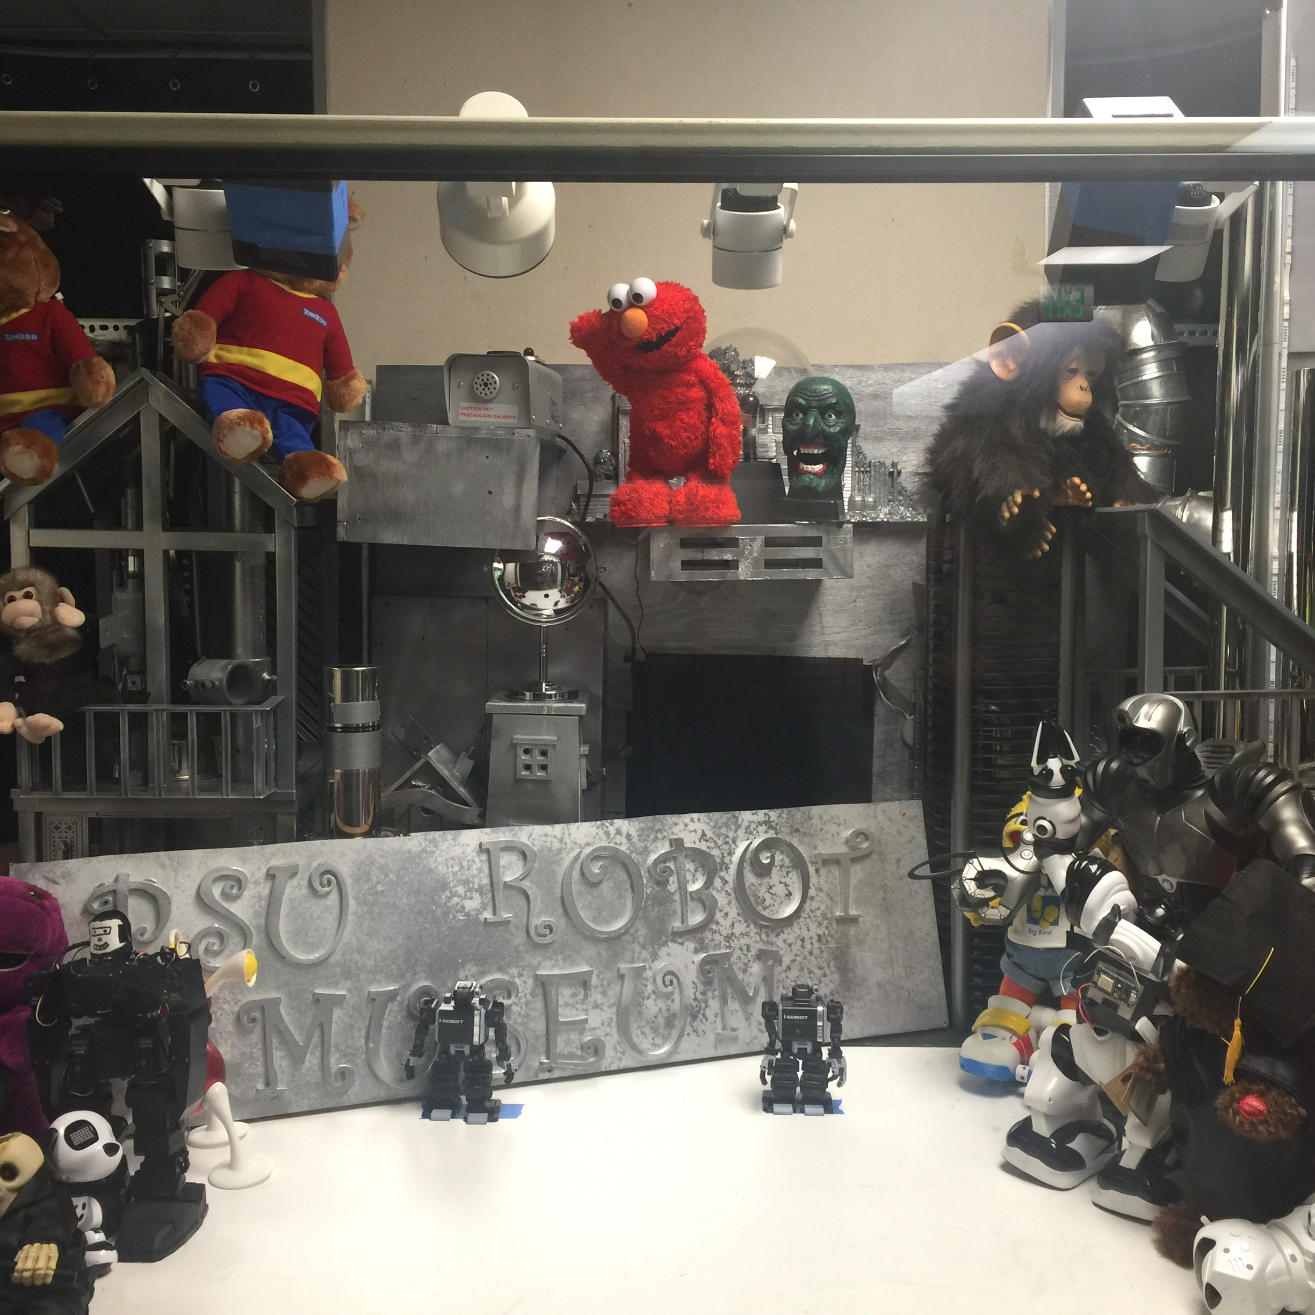
Overview of what is the initial positioning of the two IR-emitter along with the robots

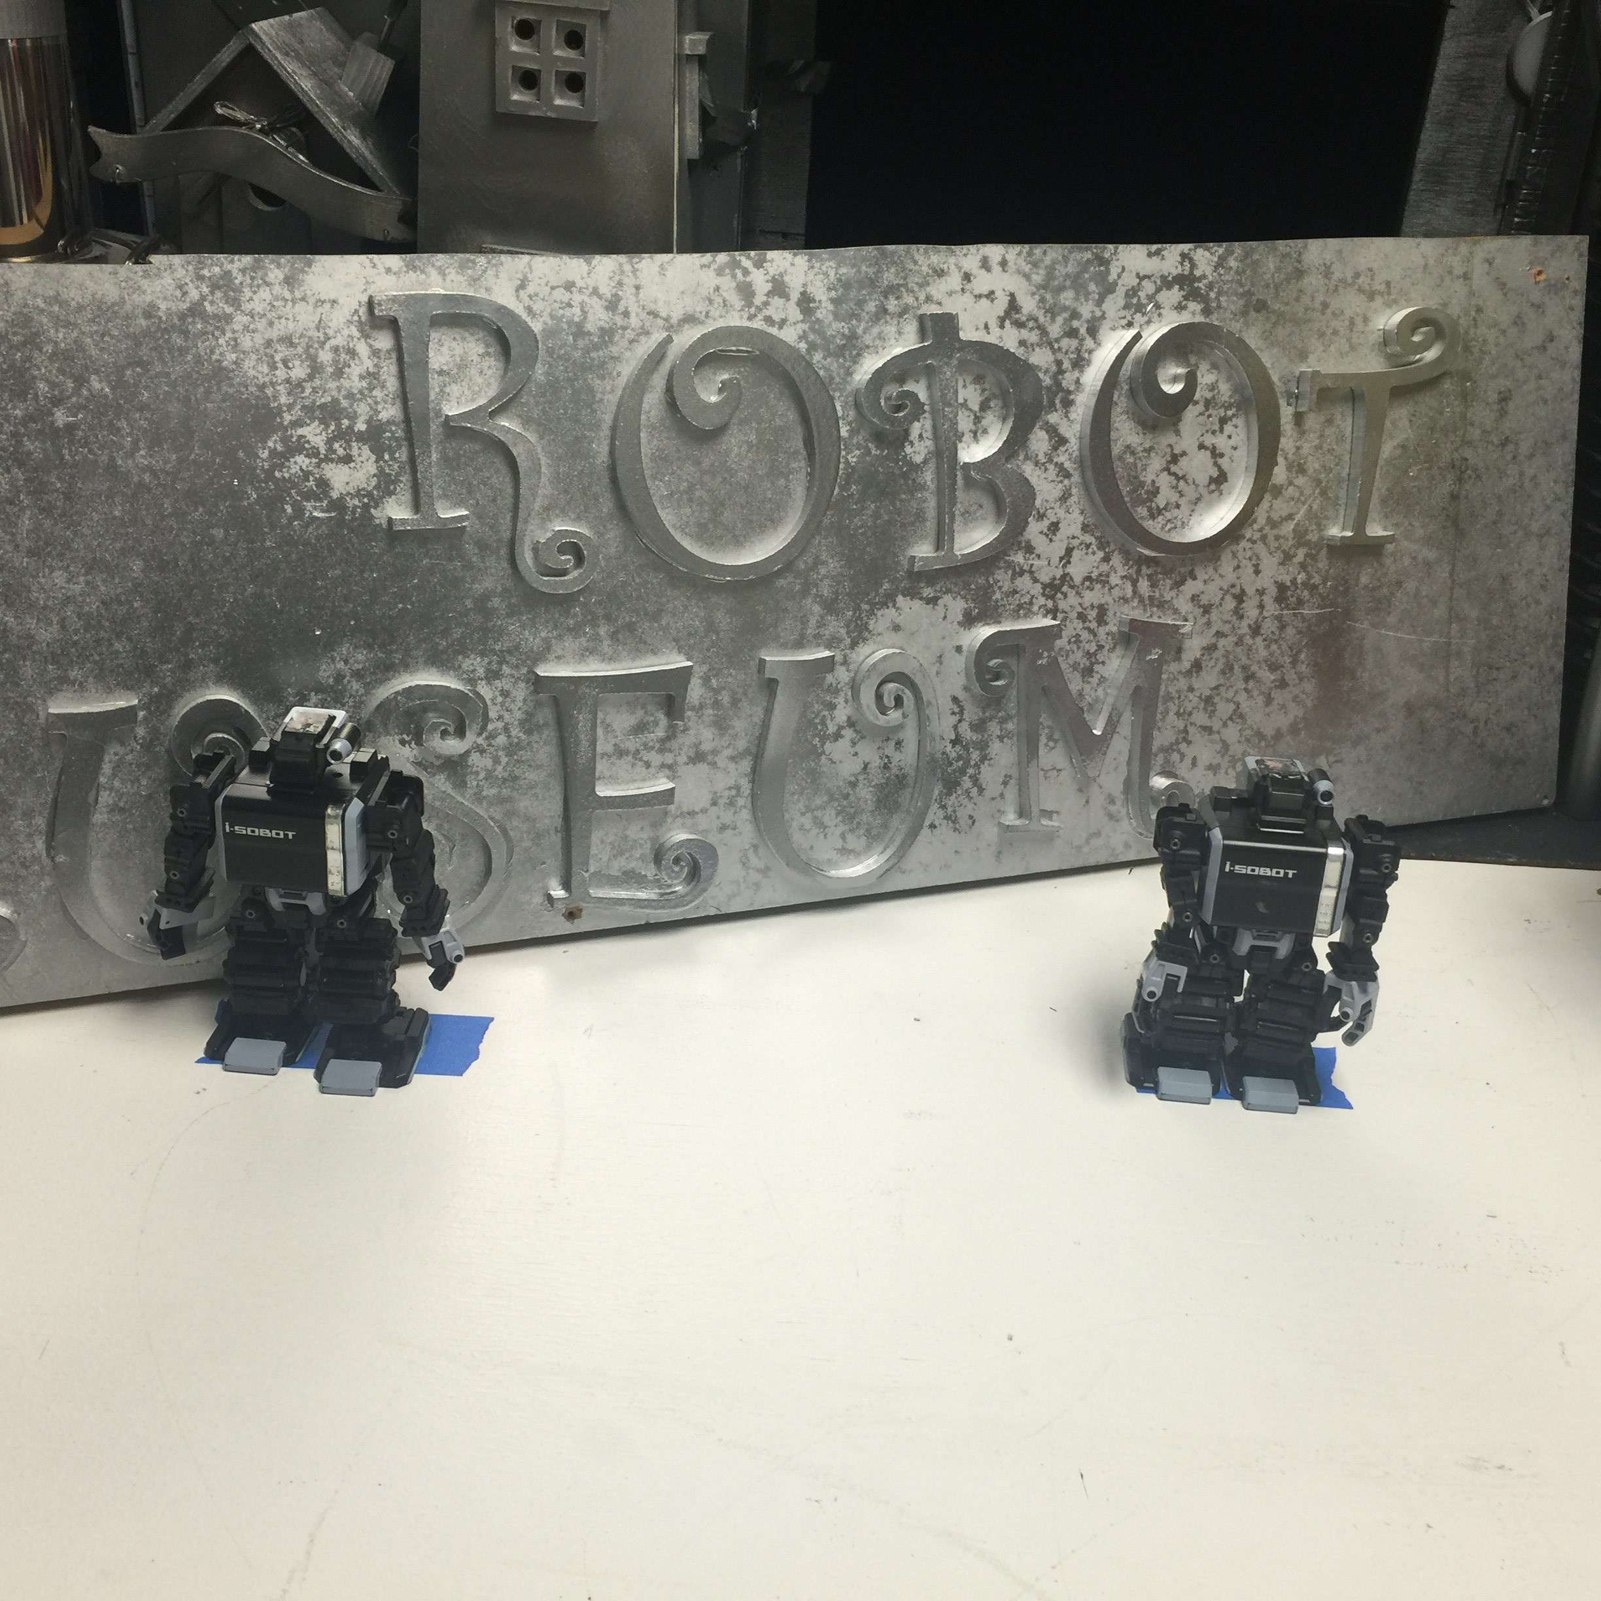
The two “Isobot robots” under the blue tape that shows the area that the IR-emitter can cover (send signal to).
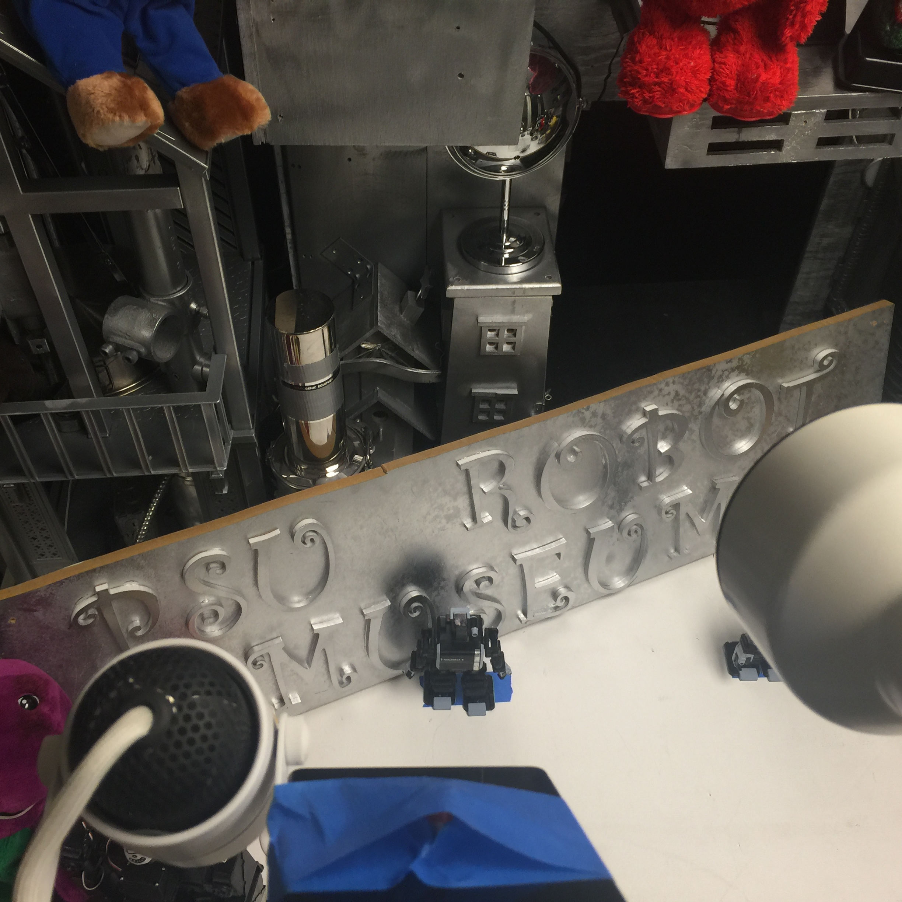
The angle of the IR-emitter scoping on the first (A) “Isobot” robot
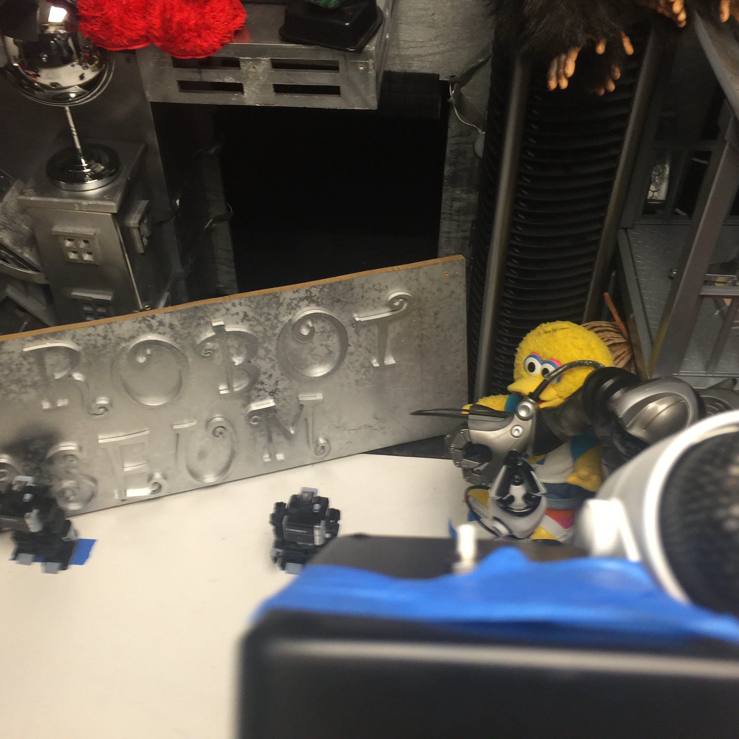
The angle of the IR-emitter scoping on the second (B) “Isobot” robot

Future Work:
- Create a complete script for the theater for the two robots to interact with each other.
- Install speakers outside the lab so people outside the lab can listen to the conversation going between the two robots.
- Use a better command sender method such as Bluetooth so robots position will not be restricted and can be controlled from a distance.
- Use a better power source since the one in there doesn’t last the robots too long.

Resources:
I have created a github and uploaded to it the Arduino code(.ino) and python code (.py)
https://github.com/waleedalhaddad/Isobot-2016/

